Vesak Bochea – To Celebrate Lord Buddha

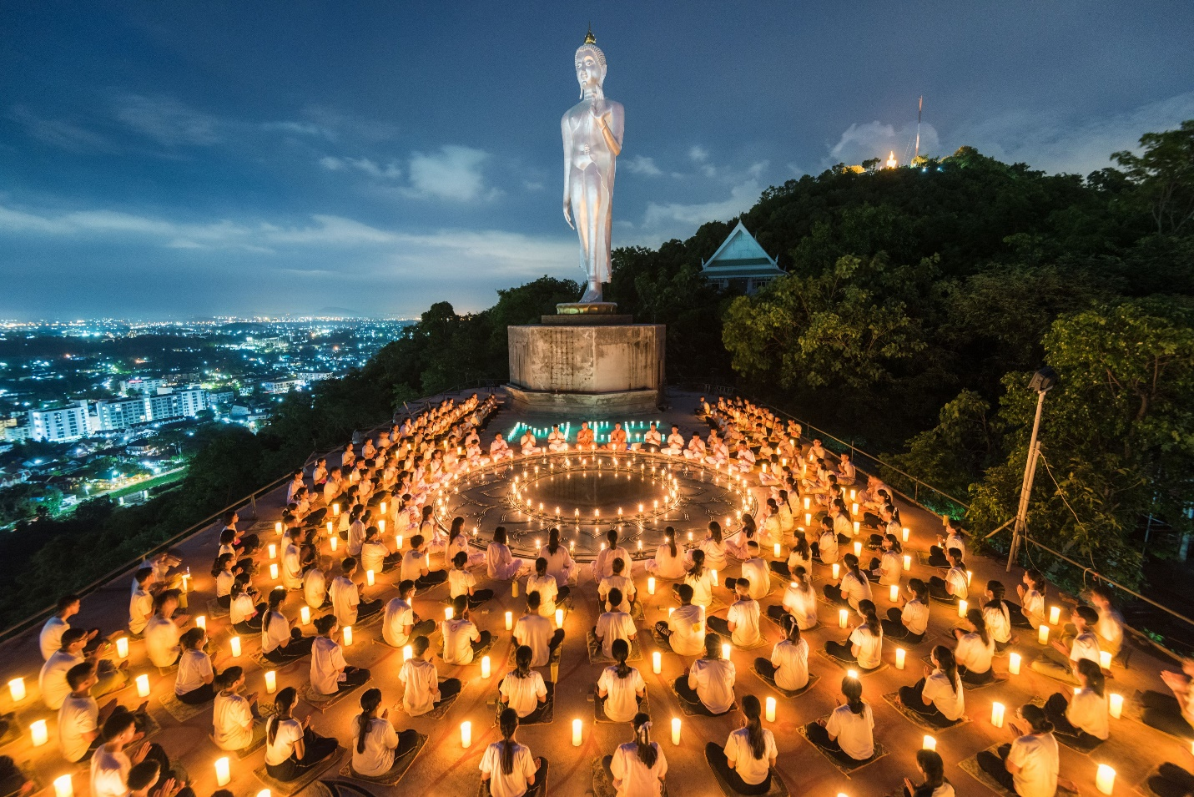

Vesak (Pali: Vesākha, Sanskrit: Vaiśākha), also known as Buddha Jayanti,Buddha Purnima and Buddha Day, is a holiday traditionally observed by Buddhists and some Hindus in South and Southeast Asia as well as Tibet and Mongolia. The festival commemorates the birth, enlightenment (Buddhahood), and death (Parinirvāna) of Gautama Buddha in Theravada and Tibetan Buddhism. In 2020, Vesak day falls on 7 May in India

In the East Asian tradition, a celebration of Buddha's Birthday typically occurs around the traditional timing of Vesak. The Buddha's awakening and death are celebrated as separate holidays that occur at other times in the calendar as Bodhi Day and Nirvana Day.

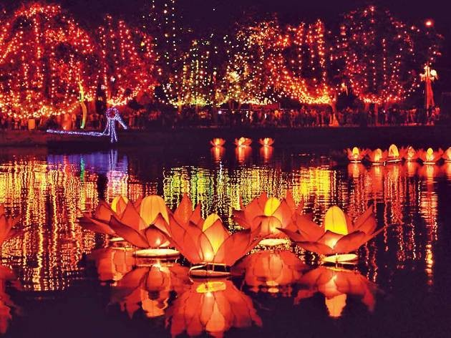

On Vesak Day, Buddhists all over the world commemorate events of significance to Buddhists of all traditions: The birth, enlightenment and the passing away of Gautama Buddha.

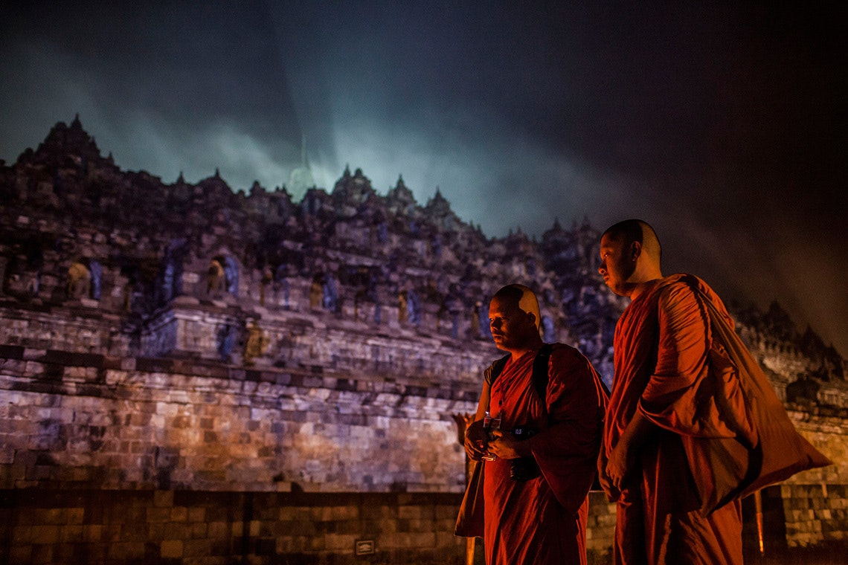

As Buddhism spread from India it was assimilated into many foreign cultures, and consequently Vesak is celebrated in many different ways all over the world.

In India, Vaishakh Purnima day is also known as Buddha Jayanti day and has been traditionally accepted as Buddha's birth day.

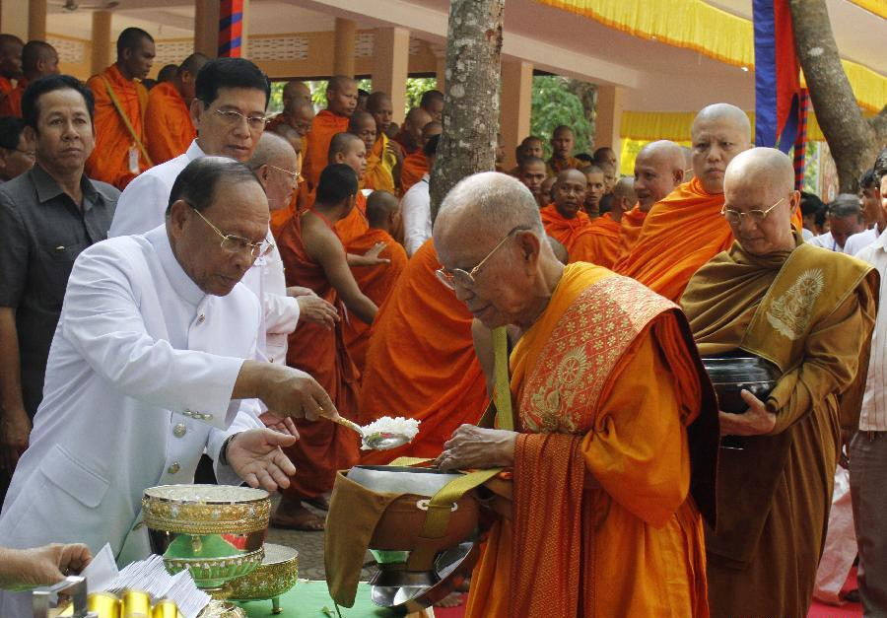

This is a single day celebration of the three major events in the life of Buddha which are, Buddha’s birth, enlightenment, and his passing into nirvana. On this day, Buddhists in Cambodia pray to Lord Buddha and donate food and clothes to the local monks in the area. This is majorly celebrated in the areas where there is a strong following of Buddhism. The date of the celebration is on every year’s 6th month’s full moon night in accordance with the Khmer lunar calendar.

**When:**7th May 2020